Effect of Inter-Ply Sequence on The Impact Behavior of Plain Weave Woven Glass/Kevlar Hybrid Composite Laminates
M. A. Kounain¹, F. Al-Sulaiman², Z. Khan³
¹Technology Transfer, Innovation and Entrepreneurship Office, King Fahd University of Petroleum and Minerals, Dhahran, Saud Arabia
² National Company of Mechanical Systems, Riyadh, Saudi Arabia
³Department of Mechanical Engineering, King Fahd University of Petroleum and Minerals, Dhahran, Saudi Arabia
Abstract: Fiber reinforced composites are susceptible to low velocity impacts where the apparently non-conspicuous impact damage may result in serious deterioration of mechanical properties of the composite material. Improving this inherent weakness of fiber reinforced composites have thus been a focus of intense research. Hybridization of the fiber reinforce composite where a number of different fiber materials are inter-plied has been one way of addressing this issue. In this study we show that the hybridization of plain weave woven glass fiber reinforced/epoxy composites with Kevlar woven fiber plies between the glass fiber plies improves the impact resistance of the glass fiber reinforced composite laminates. The results show that stacking sequence or the position of Kevlar fiber plies between glass fiber plies play a significant role on low velocity impact behavior of hybrid composites. The impact behavior of the Glass/Kevlar hybrid composites varied according to the position of Kevlar plies.
KEYWORDS: Low Velocity Impact, Glass/Kevlar, Hybrid Composites, Stacking Sequence Effect

INTRODUCTION
A hybrid composite is one in which two or more fiber or matrix systems are incorporated to form a new composite material. The aim of this hybridization process is to make a composite material that retains the advantages of each of the constituents [1-3] and offsets any disadvantages. Hybrid composite provide engineers the advantage of vast tailorability and cost effective economics. For e.g. instead of using all-Kevlar composite, a mixture of 20% (by volume) Kevlar fibers with glass fibers can produce a composite with 75% of the strength at 30% of the cost, of an all-Kevlar composite. Hybridization has also been adopted to improve the impact damage resistance of the composite [4]. Based on the geometric pattern, hybrid composites are largely classified as inter-ply and intra-ply hybrid composite. An inter-ply hybrid composite laminate is made of up of plies, where each ply could be made of a single kind of fabric material, whereas in an intra-ply hybrid composite, each ply contains two or more kind of fibers. Each of these composites is found to behave differently in terms of mechanical response, stress transfer and failure mechanism [5]. Due to the susceptibility of GFRP composites to the impact damage, several approaches are being used to improve its resistance to low velocity impact. These include improving the fiber-matrix adhesion, matrix modification and hybridization. Hybridization is now considered a favored approach as it leads to improved impact resistance without much reducing other mechanical properties [6-7]. For e.g. glass fibers provide high stiffness, high strength and load-bearing capability, whereas Kevlar fibers provide the composite with high elongation at break, more damage tolerance and better impact resistance [8-10]. Studies showed that impact of hybrid composite is found to depend on different design parameters like: geometry, laminate thickness, surface treatment and most importantly stacking sequence [11]. High-ductility fibers are found to improve the impact resistance of a brittle composite material when hybridized with the later [12]. The laminate thickness affects the locus of failure, stress distribution, and failure mechanism of composites. Thick laminates are known to be less susceptible to the impact loading than thin laminates [10]. Effect of stacking sequence on impact properties of hybrid composites is obtained by changing the position of each layer. The position of each layer changes the impact energy and energy absorption characteristics of hybrid composites [8]. It is important to understand how each of the above factors affects the impact behavior of hybrid composite. The impact behavior of hybrid composites with respect to stacking sequence and thickness is still not well understood and only few studies have thus far have addressed this issue. In this paper the effect of stacking sequence and thickness on the low velocity impact behavior of the plain weave woven Glass/Kevlar hybrid composite laminates has been explored with an aim to provide the FRP composite community with some additional insight in to composite hybridization.

MATERIALS AND METHODS

II-1-Materials
Impact behavior of plain weave woven 24-ply Glass/Kevlar hybrid composites laminates with different inter-ply stacking sequence is studied. Specification of all these materials is provided in Table 1 & Table 2 which includes the information on stacking sequence and average thickness of each. The stacking sequence is varied by varying the position of glass, carbon and Kevlar layers in the composites. Vinylester is used as resin in all the above mentioned composite materials.
Table 1. Material configurations of 24 ply Hybrid Composites
Layup | Average thickness (cm) | Density of Composite (g/cm³)
All-Kevlar | 0.55 | 1.00
All-Glass | 0.216 | 1.39
G₁₁/K₂/G₁₁ | 0.264 | 1.22
K₁/G₂₂/K₁ | 0.249 | 1.20
K₂/G₂₂ | 0.279 | 1.33
G₂₂/K₂ | 0.279 | 1.33

II-2-Impact Tests
Impact tests on each laminate was carried out using drop weight Dynatup 9250G (Instron Corp., USA) impact testing machine. 150 mm x 150 mm specimen of each laminate was clamped between two plates of the fixture (see Figure 1) and impacted once at its center and normal to the surface at an impact energy of 50J. The load transducer located between the cross head and hemispherical tup nose measured the contact force. The data acquisition system of the impact tester recorded the essential data like load, deflection, energy, time during the test.
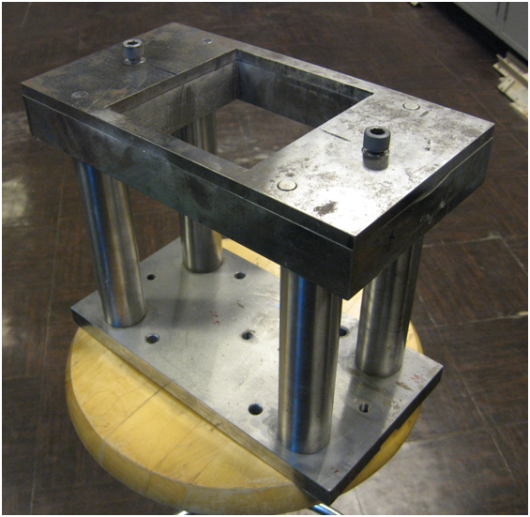
300 mm
130mm
160mm
(a)
(b)
Figure 1. Impact Test Fixture used for testing Hybrid Composites

RESULTS AND DISCUSSION
Load-time response of 24 Ply Glass, Kevlar composite laminates tested at 50J energy is shown in Figure 2. These materials include Completely Kevlar (H2) and Glass (H3) and hybridized Glass/Kevlar composite laminates based on different layups containing 22 plies of glass fabric along with 2 plies of Kevlar fabric.
The 24-ply all-Kevlar woven fabric composite laminates exhibit higher values of peak load, initiation energy and total energy due to better impact resistance of its fibers [11]. On other hand the 24-ply all-Glass woven fabric composite laminates exhibit lowest values of peak load, initiation energy and total energy due to the low impact resistance of glass fibers. But glass composite laminates exhibit higher maximum deflection due to relatively higher strain to failure of glass fibers [10]. It takes more time for glass composite laminates to reach maximum deflection compared to peak load, which means that even when load reaches maximum value, the impactor continues to move downward until it reaches the maximum displacement which implies more amount of damaged fibers [5].
Figure 2. Load Vs Time response of Glass/Kevlar 24 Ply Hybrid Composites
In Figure 3Error: Reference source not found all 24-ply Glass/Kevlar composite laminates are arranged in increasing order of their peak load values. All hybrid laminates exhibit values which were in between those exhibited by all-Kevlar and all-Glass composite laminates. In this study it is observed that when the Kevlar fabric plies are placed at the impact side (K₂/G₂₂ layup), the composite exhibits better impact behavior in terms of peak load over all other hybrid composites. The outside layers of a composite are the regions of maximum tensile or compressive strain and are affected by the prevailing fiber properties [12]. Composite laminate tends to bend under impact load based on their flexibility. By addition of 2 plies of Kevlar fabric at the impact side to 22 plies of glass fabric (K₂/G₂₂ layup) the peak load increased from 2.98 kN to 3.34 kN which is an improvement by 12%. In this lay up the two Kevlar fabric plies at the impact face undergoes large deformation due to their flexibility and the impact energy is dissipated effectively through plastic deformation of ductile Kevlar layers and the remaining energy is then absorbed by the remaining 22 layers of glass fabric. On other hand in case if the glass layers were placed at the impact side, the degree of plastic deformation is significantly reduced [6]. Load bearing capacity of a 22 ply Glass/2 ply Kevlar hybrid composite as calculated from normalized peak load comes around 3.38 kN and the peak load value of K₂/G₂₂ hybrid composite laminate is found to just near to this nominal value. Further G₁₁/K₂/G₁₁ composite was also found to be better in terms of higher peak load and energy absorbed.
Table 2. Results from Impact test of 24 Ply Glass/Kevlar Hybrid composite
 | Tested at 50J energy
Specimen | Peak Load (kN) | Energy to peak load (J) | Total energy (J) | Max Deflection (mm) | Perforation Energy (J)
Completely Kevlar | 7.78 | 35.12 | 39.22 | 10.69 | 100
Completely Glass | 2.98 | 9.50 | 27.46 | 42.67 | 20
G₁₁/K₂/G₁₁ | 3.32 | 14.09 | 33.01 | 38.65 | 25
K₁/G₂₂/K₁ | 3.00 | 10.30 | 32.40 | 38.77 | 25
K₂/G₂₂ | 3.34 | 13.65 | 32.38 | 40.2 | 25
G₂₂/K₂ | 3.00 | 11.41 | 29.77 | 42.01 | 25

Impact damage areas measured at the impact and bottom side for all 24-ply Glass/Kevlar laminates tested at 50J energy are shown in Table . Kevlar composite laminate observed lowest impact damage on the impact side due to its better impact resistance. Delamination plays a major role in absorbing impact energy in case of fiber reinforced composites and therefore it is a major factor in evaluating the impact properties of hybrid laminates [8]. Also delamination area is an indirect indicator of the composite deformation during impact. Large delamination area does not necessarily mean high impact energy [11].
Therefore the relationship between impact energy and delamination area can be better explained using Impact Energy per Delamination Area (IEDA). In spite of large damage area of glass laminate at the impact side, the composite has lower total impact energy (Table ), which means that the delamination at the interfaces did not play an effective role in absorbing the impact energy.
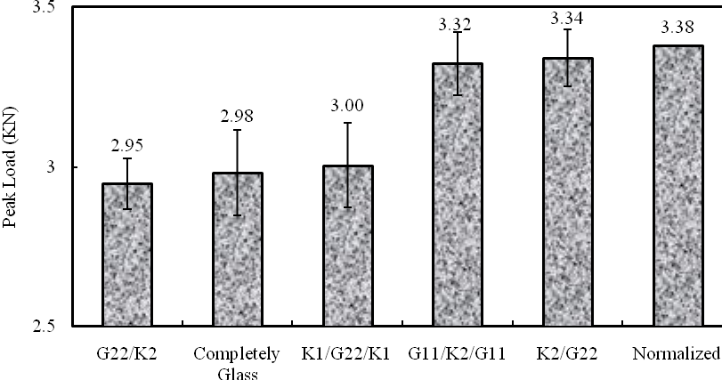
Figure 3. Peak load of Glass/Kevlar 24-Ply Hybrid Composites in increasing order
The large IEDA of all-Kevlar laminates means that much of the energy is absorbed through the process of delamination. Using total delamination area instead of damage area at bottom surface would provide better understanding about the relationship between damage area and absorbed energy. Addition of Kevlar plies to the glass in hybrid laminates reduces the damage size at the impact side.
The damage area for all composites increased from the impact (front) side to the rear (bottom) side (see Table ). This is due to the formation of cone shape damage also known as “pine tree” shape as shown in Figure 4. Delamination which is classified under inter-ply failure mode, initiates at the interface of two plies when the interlaminar shear stresses increases strongly [13]. Thickness and flexibility of composite plays a role in the type of impact damage. The crack generated at the impact side due to contact stresses induced beneath the impactor propagates downward through plies and initiate delamination at the interfaces forming a “pine tree” damage pattern [6]. Pictures of damage surface of 24-ply all-Glass and all-Kevlar composite laminates tested at 50J energy are shown in while the damage surfaces of the hybrid composite laminates are provided in Figure 6. As can be seen from these two figures, all-glass and all of the hybrid laminates except the all-Kevlar laminate (see Figure 11-a) are perforated. As shown in Table Kevlar composite laminate exhibited highest perforation threshold energy due to high impact toughness of aramid fibers which enhances the perforation resistance of the composite [11].

Table 3. Impact Damage area of Glass/Kevlar 24 Ply Hybrid Composites
Specimen | Impact Side (mm²) | Bottom Side (mm²) | Total energy (J) | IEDA (J/mm²)
Completely Kevlar | 81.56 | 521.73 | 39.22 | 0.075
Completely Glass | 469.97 | 449.42 | 27.46 | 0.061
G₁₁/K₂/G₁₁ | 439.71 | 576.05 | 33.01 | 0.057
K₁/G₂₂/K₁ | 152.22 | 576.85 | 32.40 | 0.056
K₂/G₂₂ | 141.45 | 493.46 | 32.38 | 0.066
G₂₂/K₂ | 321.11 | 424.04 | 29.77 | 0.070

Figure 4. Pine tree damage pattern
Perforation threshold of glass laminate and hybrid laminates was found to be 20 and 25J respectively. Addition of 2 Kevlar plies to the glass laminate marginally improved its perforation resistance but could not resist the perforation.
All-Kevlar composite laminates exhibits high load bearing capacity, energy to initiate damage and perforation resistance. But when these composites are hybridized with glass fabric, Glass/Carbon hybrid laminates showed better improvement in impact behavior in terms of peak load and energy to peak load than Glass/Kevlar laminates.
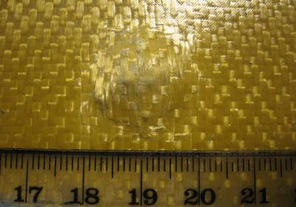
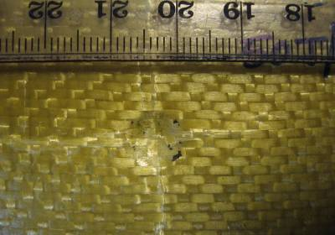
(a)

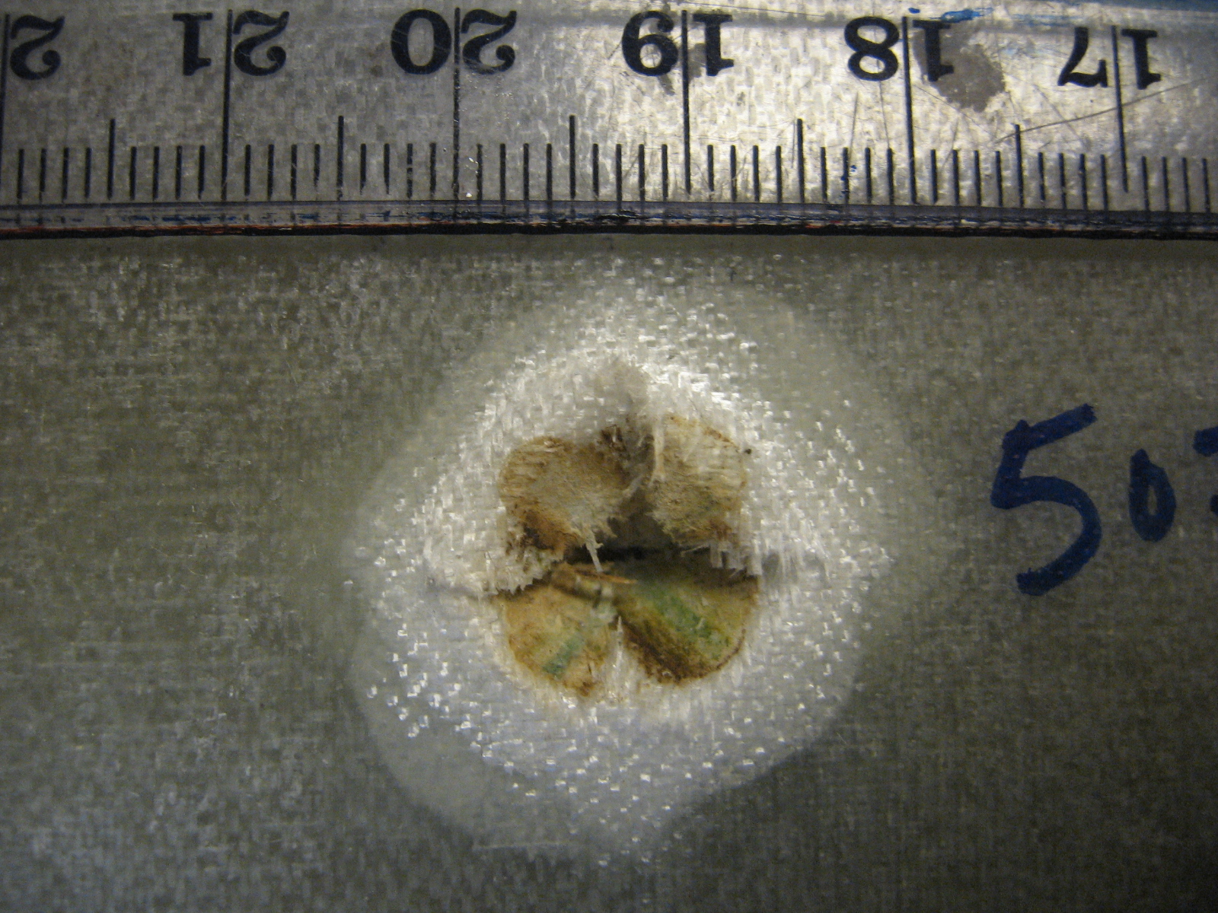
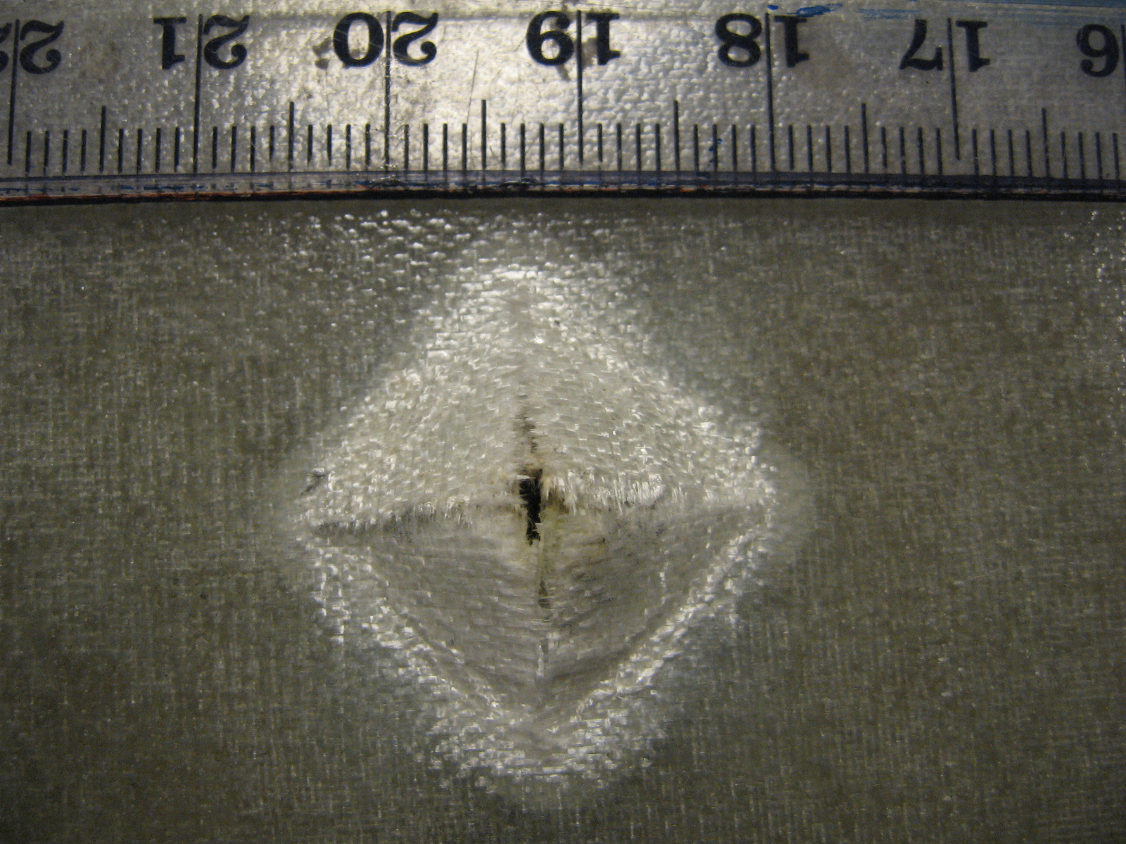
(b)

Figure 5. Impact damage on the front (left) and rear (right) surfaces of composite laminates: (a) All Kevlar (b) All Glass
C₂/G₂₂ hybrid composite showed a peak load value higher than the normalized value, on other hand K₂/G₂₂ hybrid composite laminate showed resultant peak load value less than the normalized value. This could be linked to the relative stiffness of the composite laminates involved. However the energy absorbed by K₂/G₂₂ composite was found to be marginally better than the C₂/G₂₂, which can be correlated to the flexible Kevlar layer at the impact side providing higher deflection to the composite.
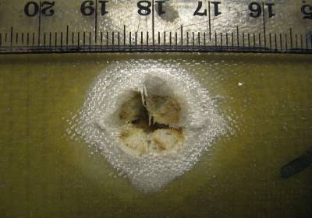
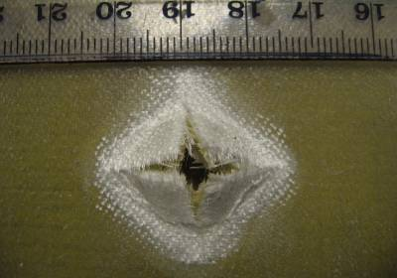
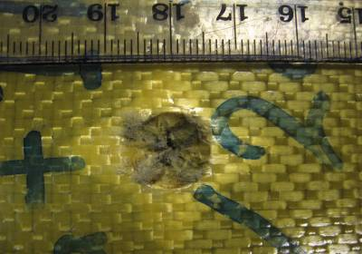
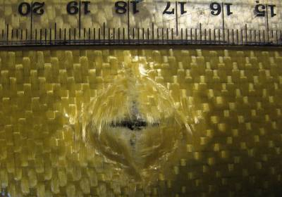
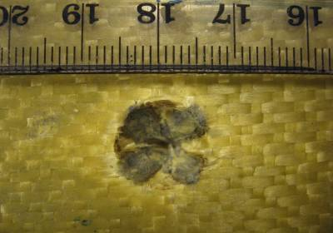
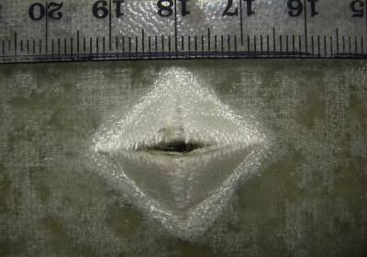
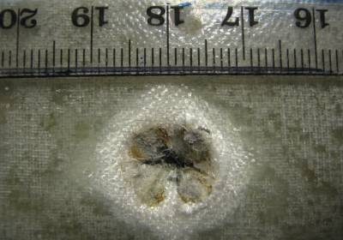
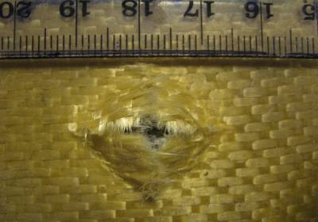
(a)
(b)
(c)

(d)

Figure 6. Impact damage on the front (left) and rear (right) surfaces of
- hybrid G₁₁/K₂/G₁₁ (b) hybrid K_{1/}G₂₂/K₁ (c) hybrid K₂/G₂₂ (d) G₂₂/K₂

CONCLUSIONS
In this study woven Glass fabric composites were hybridized with Kevlar fabric plies to improve impact resistance. All-Kevlar 24-ply woven fabric laminates showed better impact behavior compared to all-Glass 24-ply woven fabric laminates. Hybrid composites showed varied impact behavior depending on the position of the Kevlar and Glass laminas. Better impact resistance was obtained by placing 22 plies of Glass fabric at bottom, since glass fibers with higher strain to failure showed higher time to peak load. In case of Glass/Kevlar composite, Kevlar fibers undergo large plastic deformation if they are placed at the impact side and an improvement of 12% in impact resistance was observed for K₂/G₂₂ layup.
ACKNOWLEDGEMENT
The authors wish to acknowledge and thank King Fahd University of Petroleum and Minerals for supporting this research.

REFERENCES
  - Alessandro Pegoretti, Elena Fabbri, Claudio Migliaresi and Francesco Pilati, Intraply and interply hybrid composites based on E-glass and poly(vinyl alcohol) woven fabrics: tensile and impact properties, Polymer International, 2004, Vol. 53, pp. 1290–1297.
  - S. C. amico, C. C. Angrizani , M. L. Drummond, “Influence of the Stacking Sequence on the Mechanical Properties of Glass/Sisal Hybrid Composites”, Journal of REINFORCED PLASTICS AND COMPOSITES, Vol. 29, No. 2, 2010, pp 179-189
  - Cesim Atas, Onur Sayman, An overall view on impact response of woven fabric composite plates, Composite Structures, 2008, Vol. 82, pp. 336–345.
  - Hosur M.V, Adbullah M, Jeelani S, Studies on the low-velocity impact response of woven hybrid composites, Composite Structures, 2005, Vol. 67, pp. 253–262.
  - Rohchoon Park, Jyongsik Jang, Effect of Laminate Geometry on Impact Performance of Aramid Fiber/Polyethylene Fiber Hybrid Composites, Journal of Applied Polymer Science, 2000, Vol. 75, pp. 952–959.
  - Kurt Henkhaus, Overview of research on composite material impact behavior, University of Kansas.
  - Levent Onal and Sabit Adanur, Effect of Stacking Sequence on the Mechanical Properties of Glass–Carbon Hybrid Composites Before and After Impact, Journal of Industrial Textiles, April 2002, Vol. 31, No. 4, pp.255-271.
  - Rohchoon Park and Jyongsik Jang, Impact behavior of aramid fiber/glass fiber hybrid composite: Evaluation of four-layer hybrid composites, Journal of Materials Science, 2001, Vol. 36, pp. 2359 – 2367.
  - Elias Randjbaran, Rizal Zahari, Nawal Aswan Abdul Jalil, and Dayang Laila Abang Abdul Majid, “Hybrid Composite Laminates Reinforced with Kevlar/Carbon/Glass Woven Fabrics for Ballistic Impact Testing”, Scientific World Journal, 05/2014; 2014(2014):1-8. DOI: 10.1155/2014/413753
  - Kalyan Kumar Singh, Nand Kishore Singh, Ratneshwar Jha, “Analysis of symmetric and asymmetric glass fiber reinforced plastic laminates subjected to low-velocity impact”, Journal of Composite Materials, July 24, 2015, doi: 10.1177/0021998315596594.
  - Rohchoon Park and Jyongsik Jang, Impact Behavior of Aramid Fiber/Glass Fiber Hybrid Composites: The Effect of Stacking Sequence, Polymer Composites, February 2001, Vol. 22, No. 1, pp. 80-89
  - Wang C. J, Jang B. Z, Panus J and Valaire B. T, Impact Behavior of Hybrid-Fiber and Hybrid-Matrix Composites, Journal of Reinforced Plastics and Composites, July 1991, Vol. 10, pp. 356-378
  - Volnei Tita, Jonas de Carvalho, Dirk Vandepitte, Failure analysis of low velocity impact on thin composite laminates: Experimental and numerical approaches, Composite Structures, 2008, Vol. 83, pp. 413–428.

